**NDIS Information Welcome Pack**

**National Disability   
Insurance Scheme**

**The Hopwood Centre**

Leichardt Street

Echuca Regional Health

Phone: 03 5485 5801

Fax: 03 5485 5833

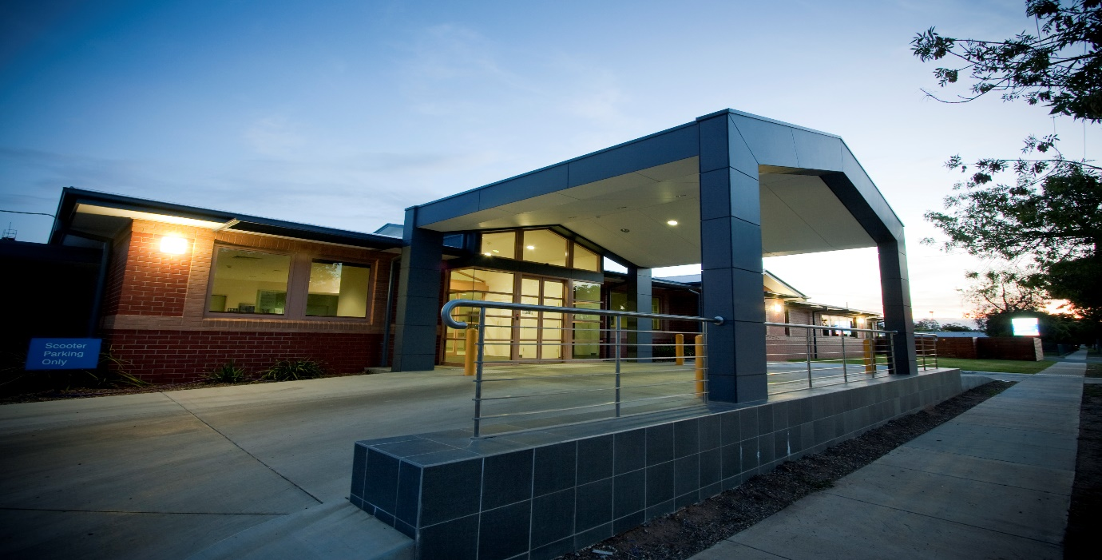 Email: [ndis@erh.org.au](mailto:ndis@erh.org.au)



EASY READ

SERVICE AGREEMENT

DESCRIPTION

WHAT IS A SERVICE AGREEMENT?



This document will help you learn about **Service Agreement**.

Service Agreementis a **document.**

It is for you and your service provider.

The **service provider** is the person or organisation that provides you with supports.



The document says that you both **agree** about the services you are going to receive.



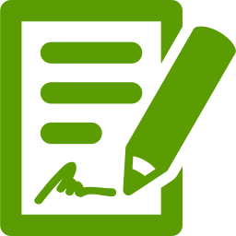

When you have agreed, you both **sign** the document.



The Service Agreement is a good way to make sure you receive the services that are right for you.

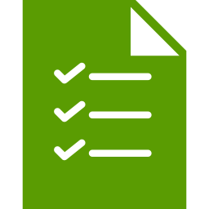

Having a Service Agreement is a helpful way to make sure you have everything in writing if any problems occur.



How to make a **Service Agreement**?

You can ask another **trusted person** to enter into the Agreement for you.

This might be a family member, carer, friend or other person.

The trusted person can speak for you.



Also, it's a good idea to take a copy of your **NDIS Plan** to any meetings you have about your Service Agreement.

If you want to, you can **attach a copy** of your NDIS Plan to the Agreement.



What should the Service Agreement **include**?



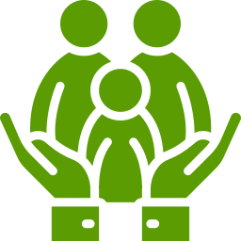

The Service Agreement should include information about the **supports** you receive.

Talk to us about your supports. Tell us:

* What type of supports you need,
* How you want the supports,
* Who you want to work with you,
* When you need supports,
* How long you will need the supports





What is expected of you -This is about your responsibilities.

What is expected of your service provider.



How you can end or change the Agreement.

What you can do if any **problems** occur.



**Costs**

* How much the service costs
* When you pay
* How to pay

Provider will talk to let you know:

* your rights
* what supports will be provided
* your responsibilities
* their responsibilities
* Of any considerations (if required)





Together we will:

* Consult and talk to each other
* Write the agreement



When do you **sign** the agreement?

(Answer on next page.)



After you or your trusted person is happy that the agreement meets your needs and that you have had your say.

After you or your trusted person has read the agreement.

After provider agrees with what is written.



Sign the agreement if you are happy to **agree** to what is written.

Once you have signed, **provider** will sign.





You will be given a copy of the Service Agreement.

Don't forget to keep a copy of your Service Agreement in a safe place.

EASY READ

RIGHTS

WHAT DO YOU KNOW ABOUT YOUR RIGHTS?

This Document is about Your **Rights**.



Our laws need to respect the rights of people with disability.

You should be included in community life.

**You have the same rights as everyone.**





What are your **rights**?



You should be:

* safe in your home and anywhere else
* treated with respect
* part of your cultural community

You should be able to:

* participate in your religion
* express your sexuality
* communicate in your family’s language





You should be able to:

* make complaints
* say if you want to go to another provider



You can tell us what you want and when you want it.

You can tell us what type of worker you want.

You can tell us how you want things done.



We will always follow your instructions, unless we feel that you may get hurt then we will talk to you or your trusted person about the risk.





EASY READ

PRIVACY

WHAT DO YOU KNOW ABOUT PRIVACY OF YOUR INFORMATION?



This Document is about Your **Privacy**.

We store information like;

* Your name, address and phone number
* People who you are close to (mum, daughter…etc)
* Details about why and how we are helping you





This helps us to support you, and to check the quality of our services. We are responsible for keeping your information **safe**.



We use your information so we can work with you to design supports to suit you.

We only share your information if you say ‘**Yes’**, or if there is a situation that makes us.



We only **share** your information

* with a **trusted** person
* when we need to so you can be safe
* with your permission to provide required information to NDIS or other government organisations





When asked to share your information you can so ‘**No’** or opt out of sharing it.

We keep your information safe so only those you say can see it.



You have several rights with your information:

* The right to see a copy of the information we hold about you
* The right to have inaccurate or incomplete information corrected by us
* The right to object to any information you think is inaccurate





If you want to see your information just ask your trusted person who will ask us.

EASY READ

INCIDENT

WHAT HAPPENS WHEN THERE IS AN INCIDENT?

This document is about what happens if there is an **incident**.



What is an **Incident?**

* Any time a provider caused you **harm**.
* Any time a provided could have caused you **harm**.
* When you **hurt** someone else.
* When someone feels that you are going to **hurt** them.
* A reportable incident (death, serious injury, abuse, neglect, sexual misconduct, restrictive practices)



We **record** what is said and done during the incident including:

* Description of what happened,
* Who saw the incident,
* When you told the worker,
* Management is told what happened.



You are important to us, so we:

* Provide **support** and assistance
* Make sure you are **safe**
* Look after your health and **wellbeing**



We will listen and talk to you or your advocate about what happened and how to fix it.





You should know what is happening so we will:

* Ask you for feedback
* Talk to you about what happened
* Consult with you or your advocate through the process.
* Your ideas about any changes that would help in the future

If we make changes to correct what happened, we will

* change our practices
* change our policies and procedures
* train our staff



There are times that we must tell NDIS Commission if there is an incident.





**For Example:**

If you or any of our participants are **badly hurt** in any way by anyone.

This is called a Critical or Reportable Incident.

What happens if there is a reportable or **critical incident**?

Management will fill out an **Incident Form.**

The Incident Report is sent to NDIS Commission.



EASY READ COMPLAINTS

HOW TO FILE A COMPLAINT OR GIVE FEEDBACK?



This document is to help you **Complain** or give us **Feedback**.

It is okay to complain if you are not happy. Tell us when you are upset about:

* Your supports
* Workers
* Echuca Regional Health





You can talk to your clinician or the **Echuca Regional Health NDIS Manager**  on 54855801 or email ndis@erh.org.au



You can ask someone **you trust** to help you complain.

You can ask an **Advocate** to help you.

An **Advocate** is someone who speaks up for you if you cannot speak up for yourself.



Not sure who to help you.

Talk to **your clinician, your Support Coordinator or LAC**  who will help you find someone.





We will try to **fix** your problem.

We will **talk** to you about your problem.



Shh!!

We will keep anything you say **private**.

**Not Happy?**

You can tell:

**NDIS Commission**

1800 03 55 44 (This is a free call from landlines)

Or online [here](https://forms.business.gov.au/smartforms/servlet/SmartForm.html?formCode=PRD00-OCF) or insert website address for this



**Call and talk to our NDIS Intake worker**

**Ph: 03 54855801**

**Email:** [**ndis@erh.org.au**](mailto:ndis@erh.org.au)

**NDIS**

**The Hopwood Centre**

**Leichardt Street**

**Echuca Regional Health**

**Ph: 0354855801**

**Fax: 0354855833**

EASY READ ADVOCACY SUPPORT



An advocate is a person who can help you to get your point of view across and be heard.



Echuca Regional Health can help you contact an advocate service or you can choose your own.

If you would like to choose an advocate, you will need to complete the “Authority to Act as an Advocate form.” We can help you complete this form if needed.





If you would like more information, please contact:

Echuca Regional Health

Ph: 5485 5897

Email: ndis@erh.org.au.